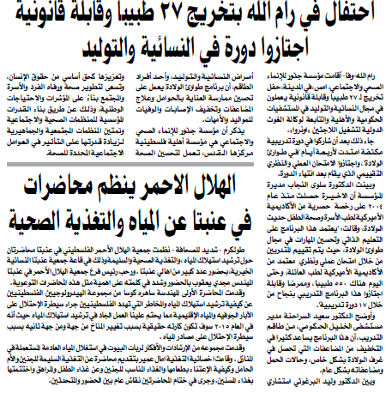

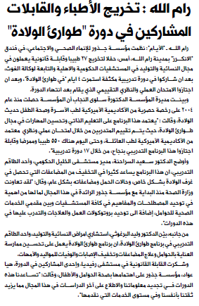

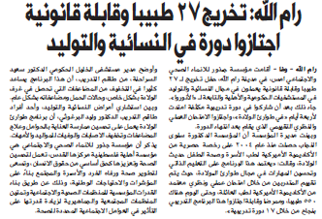

And below are the links for the websites:

http://www.maannews.net/arb/ViewDetails.aspx?ID=343917
http://www.wafa.ps/arabic/index.php?action=detail&id=93799

